- ARRAY MENU
AIM:

To create a menu for array that will perform the sorting,reverse,input,display and their sub functions.

ALGORITHM:
· stdio.h is included to perform input and output operations.
· A macro SIZE is defined to fix the size of the array.
· Function prototypes are declared for getting, displaying, reversing, and sorting array elements.
· An integer array of fixed size is declared in the main() function.
· A menu is displayed showing different array operations.
· The program repeatedly asks the user to enter a menu choice until exit is selected.
· GetArray() is called to read new elements and replace the existing array values.
· DisplayArray() is called to print all, odd, or even elements based on user choice.
· ReverseArray() is called to reverse the elements of the array.
· SortArray() is called to sort the array in ascending or descending order.
· The sorted or reversed array is displayed after each operation.
· The program exits when the user selects the exit option.
PROGRAM:

/*
* Program to Create Menu that will have differnet functionaities of Arrays
* Author : MUTHUGANESH S
* Date : 16/01/2026
* Filename : ArrayMenu.c
* retval : void
*/

#include <stdio.h>
#define SIZE 10

// Function Prototypes
void GetArray(int Array[],int Size);
void DisplayArray(int Array[],int Size,int Choice);
void ReverseArray(int Array[],int Size);
void SortArray(int Array[],int Size,int Choice);

int main(void){

int Array[SIZE];

printf("Menu for Array Operations:\n");
printf("1.Get Array\n");
printf("2.Display Array\n");
printf("3.Reverse Array\n");
printf("4.Sort Array\n");
printf("5.Exit\n");

int Choice=0,SubChoice;
while(Choice != 5){
printf("\nEnter your choice (1-5): ");
scanf("%d", &Choice);

switch(Choice){
case 1:

GetArray(Array, SIZE);
break;

case 2:

printf("1. Displaying the array elements:\n2.Odd Elements\n3.Even Elements\n");
printf("Enter your choice (1-3): ");
scanf("%d", &SubChoice);

DisplayArray(Array, SIZE, SubChoice);

break;

case 3:

ReverseArray(Array, SIZE);
break;

case 4:

printf("1.Ascending\n2.Descending\n");
printf("Enter your choice (1-2): ");
scanf("%d", &SubChoice);

SortArray(Array, SIZE, SubChoice);

break;

case 5:

printf("Exiting the program.\n");
break;

default:

printf("Invalid choice. Please try again.\n");
break;

}
}
}

//Function to get array elements from user
void GetArray(int Array[],int Size){

printf("Enter %d integers to initialize the array:\n", Size);

for(int i = 0; i < Size; i++){
scanf("%d", &Array[i]);
}
}

//Function to display array elements based on choice
void DisplayArray(int Array[],int Size,int Choice){

if(Choice==1){
printf("Array elements:\n");
}
else if(Choice==2){
printf("Odd elements:\n");
}
else if(Choice==3){
printf("Even elements:\n");
}

for(int i=0;i<Size;i++){

if(Choice == 1){
printf("%d ",Array[i]);
}
else if(Choice == 2 && Array[i] % 2 != 0){
printf("%d ",Array[i]);
}
else if(Choice == 3 && Array[i] % 2 == 0){
printf("%d ",Array[i]);
}
}
printf("\n");

}

//Function to reverse the array
void ReverseArray(int Array[],int Size){

for(int i=0;i<Size/2;i++){

int temp = Array[i];
Array[i] = Array[Size - i - 1];
Array[Size - i - 1] = temp;

}

DisplayArray(Array,Size,1);
printf("\n");
}

//Function to sort the array based on choice
void SortArray(int Array[],int Size,int Choice){

if(Choice == 1){

printf("Ascending order:\n");

// Ascending order
for(int i=0;i<Size-1;i++){
for(int j=0;j<Size-i-1;j++){

if(Array[j] > Array[j+1]){

int temp = Array[j];
Array[j] = Array[j+1];
Array[j+1] = temp;

}

}
}
}
else if(Choice == 2){

printf("Descending order:\n");

// Descending order
for(int i=0;i<Size-1;i++){
for(int j=0;j<Size-i-1;j++){

if(Array[j] < Array[j+1]){

int temp = Array[j];
Array[j] = Array[j+1];
Array[j+1] = temp;

}
}
}
}

DisplayArray(Array,Size,1);

printf("\n");
}

OUTPUT:

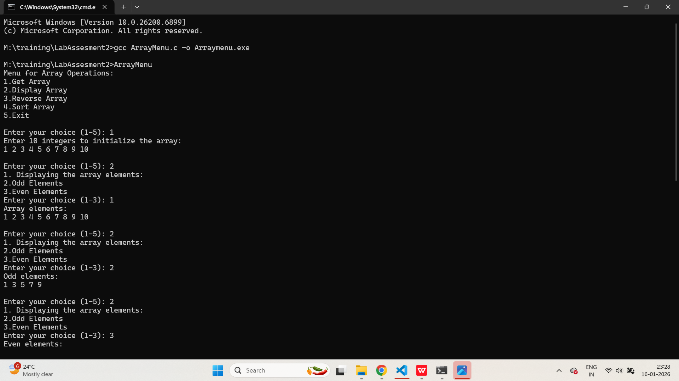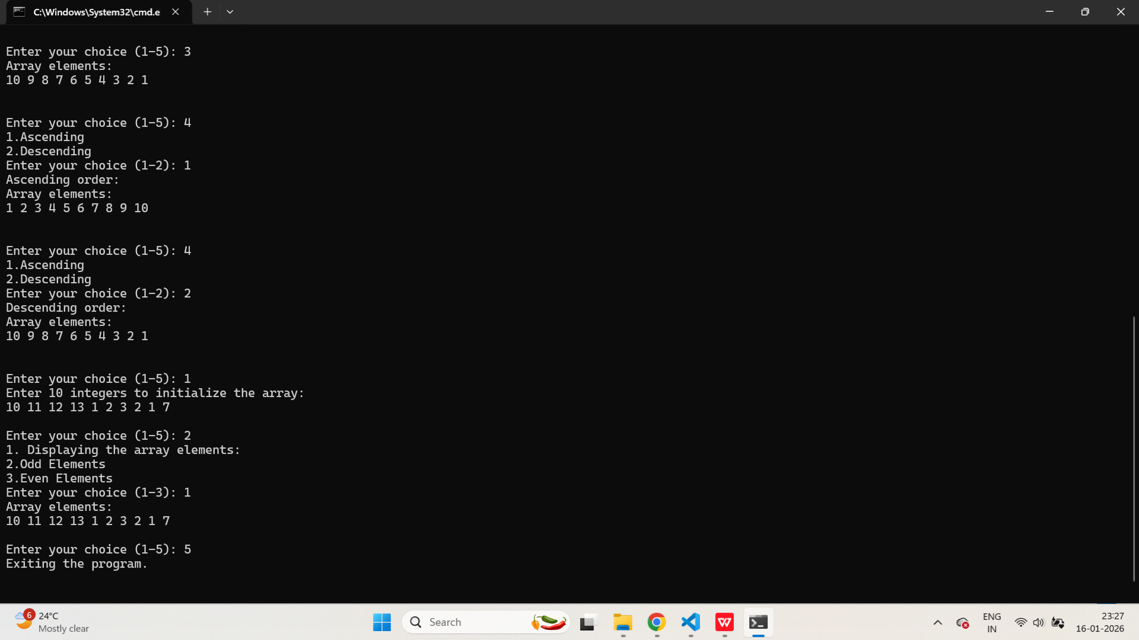

- DATES
AIM:

To create a C program to find the number of days between 2 dates using the structure.

ALGORITHM:
· stdio.h is included to perform input and output operations.
· A structure is defined to store day, month, and year values of a date.
· Function prototypes are declared to check leap year, find days in a month, and calculate days between two dates.
· Two structure variables are declared to store the input dates.
· The user enters the first date in day, month, and year format.
· The user enters the second date in day, month, and year format.
· DaysBetweenDates() is called by passing the two date structures.
· The dates are compared and swapped if the first date is later than the second date.
· The number of days is initialized to zero.
· The date is incremented day by day until it reaches the second date.
· Month and year values are updated based on the number of days in each month.
· Leap year condition is checked while calculating days in February.
· The total number of days between the two dates is returned.
· The calculated number of days is displayed on the screen.
· The program ends after displaying the result.

PROGRAM:
/*
* Program count number of days between two dates using structures
* Author : MUTHUGANESH S
* Date : 16/01/2026
* Filename : Dates.c
* retval : void
*/

#include <stdio.h>
struct Date {
int Day;
int Month;
int Year;
};
int IsLeapYear(int Year);
int DaysInMonth(int Month, int Year);
int DaysBetweenDates(struct Date Date1, struct Date Date2);

int main(void){
struct Date Date1;
struct Date Date2;

printf("Enter first date (DD MM YYYY): ");
scanf("%d %d %d", &Date1.Day, &Date1.Month, &Date1.Year);

printf("Enter second date (DD MM YYYY): ");
scanf("%d %d %d", &Date2.Day, &Date2.Month, &Date2.Year);

int Days=DaysBetweenDates(Date1, Date2);
printf("Number of days between the two dates: %d\n", Days);

return 0;
}

int IsLeapYear(int Year) {

if((Year % 4 == 0 && Year % 100 != 0) || (Year % 400 == 0))
return 1;
else
return 0;
}
int DaysInMonth(int Month, int Year) {
if(Month == 2) {
if(IsLeapYear(Year)) {
return 29;
}
else {
return 28;
}
}
else if(Month == 4 || Month == 6 || Month == 9 || Month == 11) {
return 30;
}
else {
return 31;
}
}

int DaysBetweenDates(struct Date Date1, struct Date Date2) {
if (Date1.Year > Date2.Year ||
(Date1.Year == Date2.Year && Date1.Month > Date2.Month) ||
(Date1.Year == Date2.Year && Date1.Month == Date2.Month && Date1.Day > Date2.Day)) {
struct Date Temp = Date1;
Date1 = Date2;
Date2 = Temp;
}

int Days = 0;

while (Date1.Year < Date2.Year || Date1.Month < Date2.Month || Date1.Day < Date2.Day) {
Days++;
Date1.Day++;
if (Date1.Day > DaysInMonth(Date1.Month, Date1.Year)) {
Date1.Day = 1;
Date1.Month++;
if (Date1.Month > 12) {
Date1.Month = 1;
Date1.Year++;
}
}
}

return Days;
}

OUTPUT:

